1

IN THE FIRST JUDICIAL DISTRICT COURT
- OF THE STATE OF NEVADA IN AND FOR CARSON CITY
4

- REPUBLICAN NATIONAL COMMITTEE; NEVADA
- REPUBLICAN PARTY; DONALD J.
- TRUMP FOR PRESIDENT 2024, INC.; SCOTT JOHNSTON
8
- V.
- FRANCISCO AGUILAR, in his official
- capacity as Nevada Secretary of State; State of NEVADA; CARI-ANN
- BURGESS, in her official capacity as
- the Washoe County Registrar of Voters; JAN GALASSINI, in her
- official capacity as the Washoe County
- Clerk; LORENA PORTILLO, in her official capacity as the Clark County
- Registrar of Voters; LYNN MARIE
- GOYA, in her official capacity a Clark County Clerk.
18
Case No.:

Dept. No.:

COMPLAINT FOR DECLARATORY AND INJUNCTIVE RELIEF
Arbitration Exemption: Declaratory and Injunctive ief

- Plaintiffs Republica ional Committee and the Nevada Republican Party,
- Donald J. Trump for 1 ent 2024, Inc., and Scott Johnston, by and through
- undersigned counsel, this Complaint against Francisco Aguilar, in his official
- capacity as Nevada Secretary of State; the State of Nevada; Cari-Ann Burgess, in her
- official capacity as the Washoe County Registrar of Voters; Jan Galassini, in her
- official capacity as the Washoe County Clerk; Lorena Portillo, in her official capacity
- as the Clerk County Registrar of Voters; and Lynn Marie Goya, in her official capacity
- as the Clark County Clerk; and allege as follows:

NATURE OF THE CASE
- 1. Nevada law permits the counting of some ballots received by mail after

  - election day, within time limits established by the Nevada legislature. This lawsuit
  - seeks to enforce one critical component of Nevada's post-election day counting of
  - ballots: the requirement that mail ballots received after election day but lacking a
  - postmark are not counted, as set forth in NRS 293.269921(1)-(2).
  - 2. This lawsuit is necessary because the Nevada Deputy Secretary of State
  - for Elections recently testified that this key safeguard of Nevada law will be ignored
  - in upcoming elections and that mail ballots without a postmark will be counted if
  - received up to 3 days after election day. See Deputy Secretary of State for Elections
  - Mark Wlaschin, testimony before Nevada Advisory Committee on Perspiratory
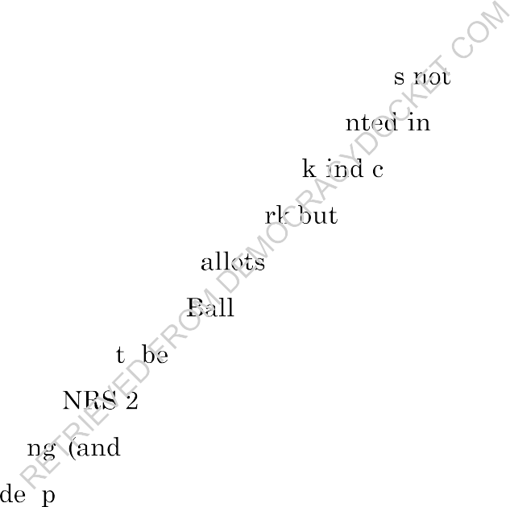
  - Democracy, April 23, 2024, available at 4/23/2024 - Secretary of State -Advisory Committee
  - on Participatory Democracy - YouTube (starting at 1:30:09).
  - 3. Counting non-postmarked mail ballots i permitted by Nevada law,

  - which allows late-arriving mail ballots to be cou
  - the ballot is accompanied by a valid postmar
only two circumstances: (1) i ating it was mailed on or before

  - election day, or (2) the ballot has a postma "the date of the postmark cannot be
  - determined." Legibly postmarked b are counted if received four days after
  - election day. NRS 293.269921(1). ots bearing postmarks with dates that are
  - illegible or otherwise canno determined are appropriately given a shorter
  - timeframe of three days. 93.269921(2).
  - 4. In enacti recently amending) section 293.269921, the Nevada
  - legislature has ma olicy judgments about which mail ballots received after
  - election day may be counted. In closely contested elections (and all elections), care
  - must be taken to ensure that ballots cast after election day cannot be counted. Indeed,
  - it is axiomatic to fair elections that once the time for voting has ended, no interested
  - party can add new votes to the mix. The unfairness and opportunity for changing the
  - valid results of an election are self-evident.
  - 5. Plaintiffs seek a declaration and injunction to ensure that Nevada voters
  - will have confidence that only those late-arriving mail ballots with evidence of having

- been mailed on or before election day will be counted, as the Nevada legislature
- intended when it required the presence of a postmark before such late-arriving mail
- ballots may be counted.

4 |  | JURISDICTION AND VENUE
5 | 6. | This Court has jurisdiction to hear Plaintiffs' claims and to grant
6 | declaratory | and injunctive relief pursuant to NRS 295.061, 30.030, 30.040, and
7 | 33.010.
8 | 7. | Venue is proper under NRS 13.020 and 13.040 because this action is
- against a public officer, certain Defendants are located within the instant judicial
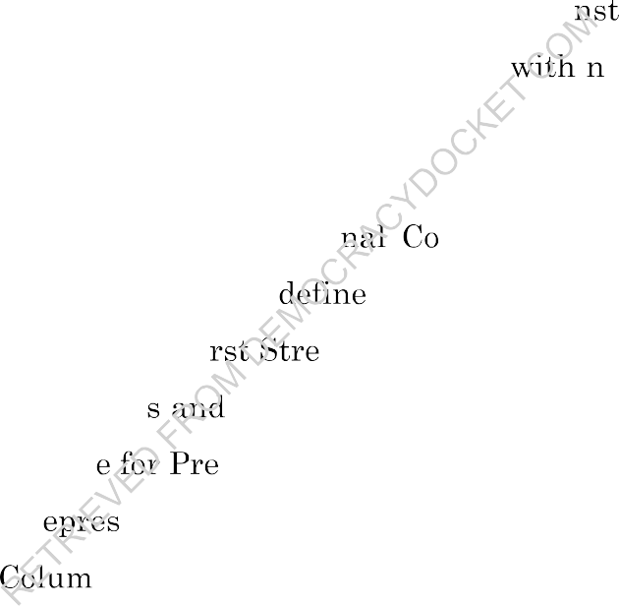
- district, the acts complained of herein occurred within the i ant judicial district,
- and the relief Plaintiff seeks would be granted from 1 the instant judicial
- district.

PARTIES

- 8. Plaintiff, the Republican Natio
- committee of the Republican Party, as
mmittee (RNC), is the national d by 52 U.S.C. § 30101(14), with its

- principal place of business at 310 Fi
- 9. The RNC organize
- which nominates a candidat
et S.E., Washington, DC 20003.
operates the Republican National Convention, sident and Vice President of the United States.

- 10. The RNC r ents over 30 million registered Republicans in all 50
- states, the District of bia, and the U.S. territories. It is comprised of 168 voting
- members representing state Republican Party organizations, including three
- members who are registered voters in Nevada.
- 11. The RNC works to elect Republican candidates to state and federal office
- in Nevada. In the November 2024 general election, Republican candidates will appear
- on the ballot in Nevada for election to the Presidency, U.S. Senate, U.S. House of
- Representatives, and state offices.
- 12. The RNC has vital interests in protecting the ability of Republican
- voters to cast, and Republican candidates to receive, effective votes in Nevada

- elections and elsewhere.
- 13. The RNC seeks to vindicate its own rights and represent the rights of
- its members, affiliated voters, and candidates.
- 14. The RNC has a strong interest in ensuring that elections in which it and
- its candidates compete for votes are conducted in a legally structured competitive
- environment.
- 15. The RNC devotes significant resources to mail-ballot-chasing operations
- and election integrity activities, including post-election day activities, such as
- monitoring the processing and counting of mail ballots. If non-postmarked ballots
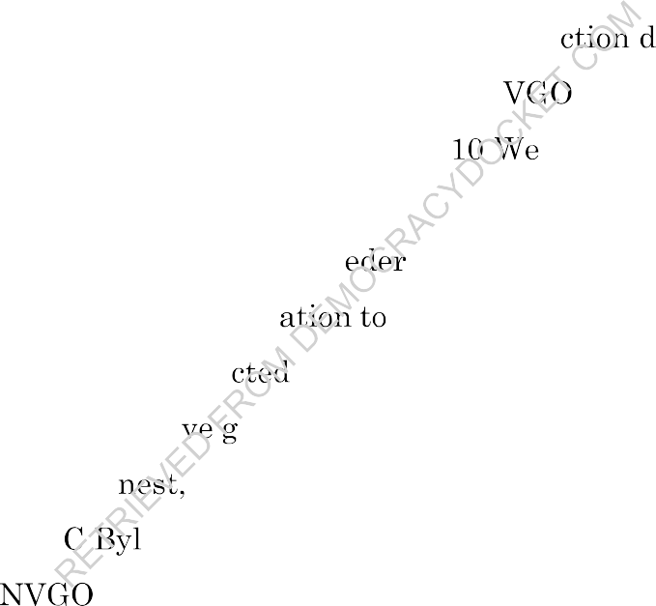
- received after election day are counted, the RNC will have to devote resources to
- ascertaining and ensuring that only ballots mailed by ele ay are counted.
- 16. Plaintiff Nevada Republican Party (N P) is a political party m
- Nevada with its principal place of business at 28 st Charleston Blvd. #69, Las
- Vegas, NV 89102.

- 17. The NVGOP exercises its f
- speech, assembly, petition, and associ
al and state constitutional rights of "provide the statutory leadership of the

- Nevada Republican Party as dire
- develop, and elect representati
in the Nevada Revised statutes," to "recruit, overnment at the national, state, and local levels,"

- and to "promote sound, ho
- and local levels." NRC
and representative government at the national, state aws, art. II, §§1.A-1.C.

- 18. The
- Nevada.
P represents over 550,000 registered Republican voters in

- 19. The NVGOP has the same interests as the RNC in vindicating its own
- rights, preserving resources, and representing the rights of its members, affiliated
- voters, and candidates.
- 20. Plaintiff Donald J. Trump for President 2024, Inc. (Trump Campaign) is
- the principal committee for President Donald J. Trump's campaign for President with
- its headquarters in West Palm Beach, FL.

  - 21. Donald J. Trump will be a candidate for President on the ballot for the
  - 2024 Nevada general election (by and through presidential and vice presidential
  - electors) and is a Republican affiliated with the RNC and NVGOP.
  - 22. The Trump Campaign has the same interests in this case as the RNC
  - and NVGOP with respect to the candidacy of President Trump and seeks to vindicate
  - those interests in the same ways. The Trump Campaign intends to invest resources
  - seeking voter support for the Nevada general election.
  - 23. Plaintiff Scott Johnston is a 60-year resident of Nevada and a registered
  - Nevada voter residing in Washoe County. He regularly votes in Nevada elections, and
  - he plans to vote in the November 2024 general election, including for U.S. President,

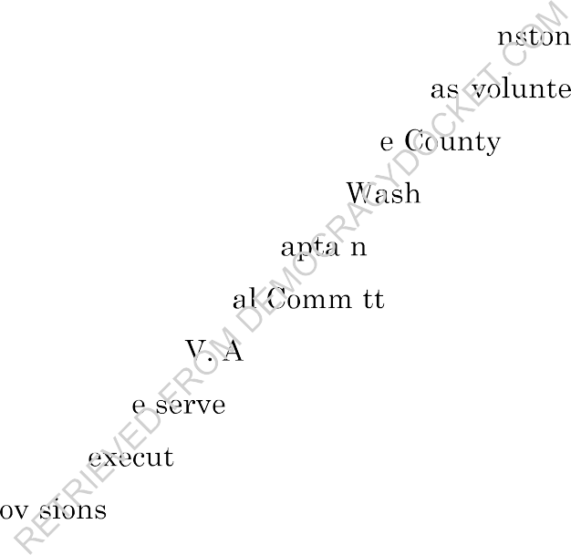
  - Senate, and the House of Representatives. Mr. Joh
  - Republican, supports Republican candidates, and h
  - Republican Party. He is a member of the Washo
is registered as a ered on behalf of the Republican Party Central

  - Committee, which is the governing body of the
  - Johnston has also served as a precinct c
  - since 2020, and a Nevada State Centr
oe County Republican Party. Mr.
1 for the Galena Forest Estates area
1 ee person since 2021.

  - 24. Defendant Francisco
  - sued in his official capacity. H
guilar is the Nevada Secretary of State and is s "as the Chief Officer of Elections" for Nevada

  - and "is responsible for the ion and enforcement of the provisions of title 24 of
  - NRS and all other pr 1 of state and federal law relating to elections in" Nevada.
  - NRS §293.124.
  - 25. Defendant State of Nevada is a political jurisdiction and State of the
  - United States.
  - 26. Defendant Cari-Ann Burgess is the Registrar of Voters for Washoe
  - County. She is the county's chief election officer and is responsible for "establish[ing]
  - procedures for the processing and counting of mail ballots" in Washoe County. NRS
  - 293.269925(1); see id. 293.269911-.269937, 244.164. Defendant Burgess is sued in her
  - official capacity.

    - 27. Defendant Jan Galassini is the Washoe County Clerk. She is responsible
    - for certifying the election results in Washoe County. NRS 293.393. Defendant
    - Galassini is sued in her official capacity.
    - 28. Defendant Lorena Portillo is the Registrar of Voters for Clark County.
    - She is the county's chief election officer and is responsible for "establish[ing]
    - procedures for the processing and counting of mail ballots" in Clark County. NRS
    - 293.269925(1); see id. 293.269911-.269937, 244.164. Defendant Portillo is sued in her
    - official capacity.
    - 29. Defendant Lynn Marie Goya is the Clark County Clerk. She is
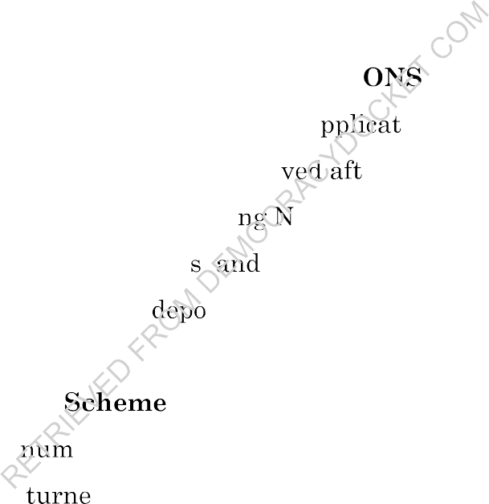
    - responsible for certifying the election results m Clark County. NRS 293.393.
    - Defendant Goya is sued in her official capacity.

GENERAL ALLEGATI

    - 30. Nevada citizens rely on consistent a
    - free and fair elections. How mail ballots recei
ion of election rules to ensure er election day are counted is an

    - issue of critical importance for the upcomi
    - only have confidence in the fairnes
evada general election. The public will finality of the election if Nevada law

    - requiring ballots to be voted and
    - fully enforced.

A. Nevada Statutory
sited in the mail on or before election day is

for Late-Arriving Mail Ballots.

    - 31. There are
    - A mail ballot may be re
    - by mail.
erous opportunities to vote in Nevada, including by mail. d in person, deposited in a ballot drop box, or returned

    - 32. Nevada provides for mail ballots to be sent to all active registered voters
    - who do not opt out of receiving a ballot by mail, and Nevada includes postage pre­
    - paid return envelopes for returning mail ballots.
    - 33. Since 2020, Nevada law has provided that ballots returned by mail may
    - be counted provided there is evidence they were voted on or before election day but
    - were not received by the clerk and recorder until after election day. (Prior to 2020,

- Nevada law did not permit the counting of any absent ballots received in the mail
- after election day. See NRS 293.317 (2019)). These late-arriving ballots are subject
- to strict limits, as would be expected for the counting of additional ballots received
- after the election has been completed and the polls have closed.
- 34. Under Nevada law, "[l]n order for a mail ballot to be counted for any
- election, the ballot must be ... [m]ailed to the county clerk," "postmarked on or before
- the day of the election," and "[r]eceived by the clerk not later than 5 p.m. on the fourth
- day following the election." NRS 293.269921(1).
- 35. Nevada law further provides that "[i]f a mail ballot is received by mail
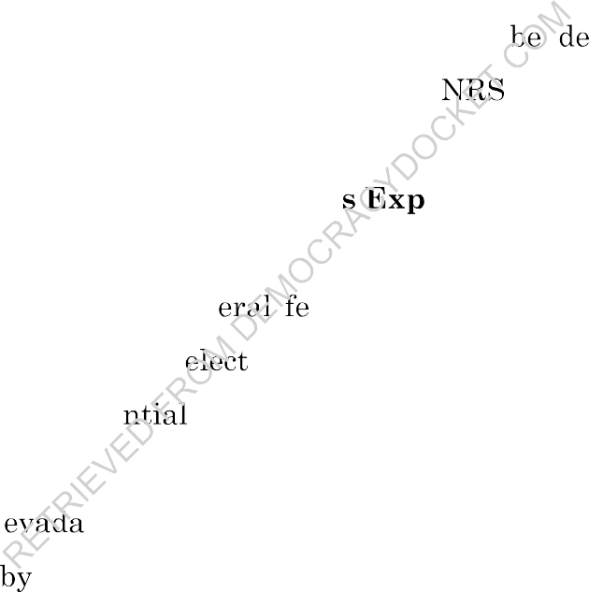
- not later than 5 p.m. on the third day following the election and the date of the
- postmark cannot be determined, the mail ballot shall emed to have been
- postmarked on or before the day of the election." 293.269921(2) (emphasis
- added).

- B. The 2024 Nevada General Election i
- Mail Ballot Returns
ected to have Substantial

- 36. Nevada will hold a gen
- addition to many local and state
deral election on November 5, 2024. In ion matters, the general election will select

- presidential and vice preside electors and elect Representatives and a U.S.
- Senator from the State.
- 37. Under N law, mail ballots "postmarked on or before" November 5,
- 2024, and "[r]eceived the clerk not later than 5 p.m." on November 9, 2024, will be
- counted. NRS 293.269921(1).
- 38. Under Nevada law, postmarked mail ballots whose postmark date
- "cannot be determined" will be counted if received on or before 5 p.m. on November
- 8, 2024. NRS 293.269921(2).
- 39. On April 23, 2024, the Deputy Secretary of State for Elections, Mark
- Wlaschin, testified before the Nevada Legislature's Advisory Committee on
- Participatory Democracy that Nevada's policy and practice is to count mail ballots

- "without a postmark" if they are received within three days of election day. See
- Deputy Secretary of State for Elections Mark Wlaschin, testimony before Nevada
- Advisory Committee on Perspiratory Democracy, April 23, 2024, available at
- 4/23/2024 - Secretary of State - Advisory Committee on Participatory Democracy - YouTube
- (starting at 1:30:09).
- 40. The Secretary of State participates or sends a designee to participate in
- the Advisory Committee on Participatory Democracy, which was created pursuant to
- NRS Chapter 225.
- 41. Upon information and belief, consistent with Deputy Secretary
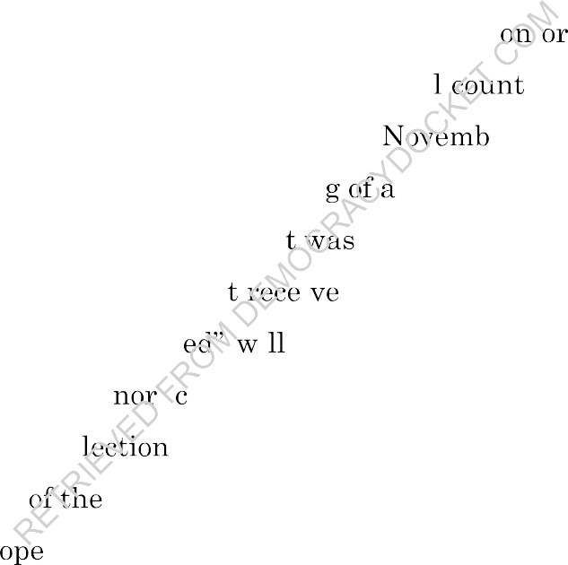
- Wlaschin's testimony, election officials in Nevada have counted and will continue to
- count mail ballots that lack a postmark and are received before 5 p.m. on the
- third day following the election. Election officials wil mail ballots that lack a
- postmark and are received on or before 5 p.m. on er 8, 2024.
- 42. Nevada law permits the countin mail ballot received after election
- day only if it bears a postmark indicating i mailed on or before election day. The
- law further provides that a mail hallo 1 dafter election day where "the date of
- the postmark cannot be determin 1 be counted if received within three days
- after election day. This mi aveat to the law requiring mail ballots to be
- postmarked on or before e day applies where the mail ballot envelope has a
- postmark but the date postmark cannot be determined. It does not apply when
- the mail ballot envel lacks any postmark whatsoever.
- 43. USPS routinely delivers mail inside of three days within Nevada. For
- example, the online Service Standard Map for first class mail originating in any Las
- Vegas zip code shows the letter will be delivered to the Clark County Elections
- Department within two days:
26

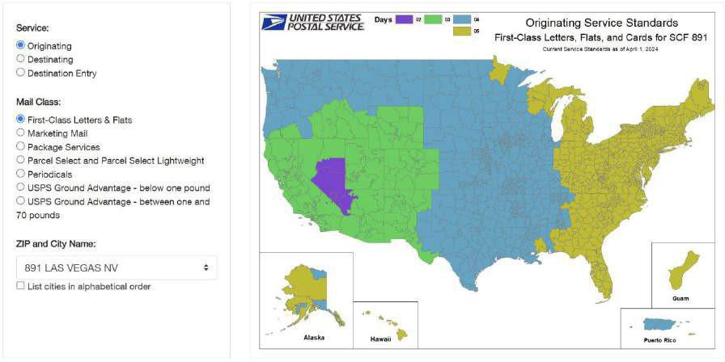
1
2
  - 44. It is therefore possible, if not proba at mail ballots deposited in the
  - mail after election day could arrive at mail- ot processing facilities within the
  - three-day deadline, and under Dep ecretary Wlaschin's erroneous legal
  - interpretation, those untimely hallo ould be counted if they do not bear a
  - postmark.
  - 45. A postmark is d on mail received by the U.S. Postal Service
  - (USPS) and indicates w 1 PS office accepted the mail, including the state, zip
  - code, and date of m often with markings indicating the postage has been
  - canceled and cannot be reused.
  - 46. Upon information and belief, some mail ballots will be received by Clark
  - and Washoe County election officials after election day which lack any postmark.

C. Plaintiffs necessarily rely on Nevada's statutory ballot-counting
  - regime.
  - 47. The RNC, NVGOP, and Trump Campaign rely on provisions of Nevada
  - law in conducting their campaigns, which include resources allocated to the post-
  - election counting and certification processes.

    - 48. For example, Nevada law guarantees Plaintiffs the right to be
    - represented on county mail ballot central counting boards. See NRS 293.269929(2)
    - ("The voters appointed as election board officers for the mail ballot central counting
    - board must not all be of the same political party."). Nevada law also guarantees the
    - right to observe the handling and counting of mail ballots. See NRS 293.269931(1);
    - Nev. Admin. Code 293.322(3), (4); 356(1). Counting all ballots received within three
    - days after Election Day, including non-postmarked ballots, requires Plaintiffs and
    - their members to divert more time and money to post-election mail ballot activities.
    - See NRS 293.269931 (counting may continue up to "the seventh day following an
    - election").

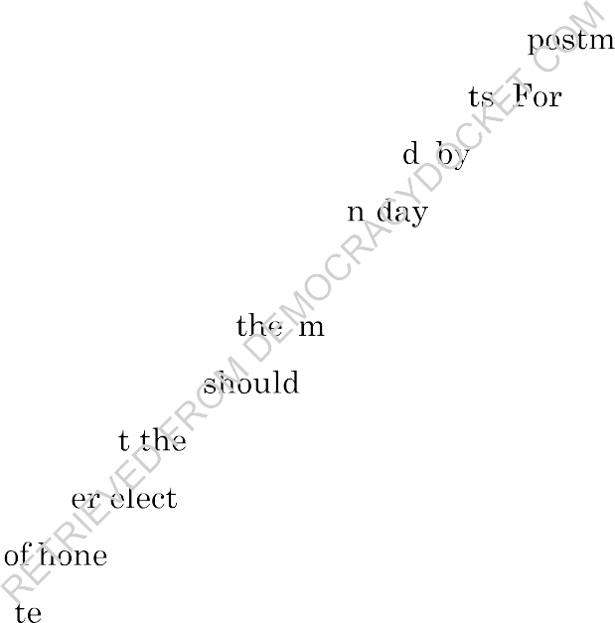
    - 49. In addition, late-arriving ballots without a
    - counting them dilutes the weight of timely, valid ballo
ark are not valid, so instance, if 1,000 ballots

    - are mailed after election day and then counte
    - postmark, the valid votes on or before electio
    - of those 1,000 unlawfully counted ballots.
Nevada because they lack a would be diluted by the counting

    - 50. Any votes deposited in
    - would not be legally cast votes and
ail after the polls close on election day not be counted.

    - 51. It is possible tha results of a close election could be changed by the
    - counting of ballots cast aft ion day.
    - 52. Dilution st votes, to any degree, by the counting of late-cast votes
    - violates the right to vo and prevents the holding of a free and fair election.
    - 53. Voting by mail is highly polarized by party, meaning the dilution of votes
    - on account of late-arriving mail ballots directly and specifically harms Plaintiffs. For
    - example, according to the MIT Election Lab, 46% of Democratic voters in the 2022
    - General Election mailed in their ballots, compared to only 27% of Republicans.
    - Charles Stewart III, How We Voted in 2022, at 10 https://perma.cc/444Z-58ZY.
    - Accordingly, late-arriving mail ballots that are counted will tend to
    - disproportionately favor Democrat candidates.

      - 54. In Nevada, voting by mail is even more polarized by party. For example,
      - m Nevada's 2020 general election, 60.3% of Democratic voters voted by mail,
      - compared to just 36.9% of Republican voters. See Nev. Sec'y of State, 2020 General
      - Election Turnout, https://perma.cc/Z6F3-SM4N. Likewise in the 2022 general
      - election, 61.3% of Democrats and just 40% of Republicans voted by mail. See Nev.
      - Sec'y of State, 2022 General Election Turnout, https://perma.cc/N7G7-RUQ9.
      - 55. Moreover, mail ballots from Democrat affiliated voters frequently arrive
      - late, in part because "Democratic get-out-the-vote drives-which habitually occur
      - shortly before election day-may delay maximum Democratic voting across-the­
      - board, and produce a 'blue shift' in late mail ballots." Ed Kil ore, Why Do the Last
      - Votes Counted Skew Democratic?, Intelligenc (Aug. 10, 2020),
      - https://perma.cc/R78D-3Q58. Indeed, "even if Repub i and Democrats voted in
      - person and by mail at identical levels, Democra to vote later, which in turn
      - (particularly in elections with heavy voting by means early Republican leads in
      - close races could be fragile." Id.
      - 56. Indeed, data from the Secretary of State's office and county

      - election offices indicates that th
      - ballots from registered Demo
      - 2020 and 2022 general ele
ere approximately 50% more late-arriving voters than registered Republican voters in the

      - 57. In the 20 da election for U.S. Senate, media reported that late-
      - arriving mail ballots avored the Democrat and helped swing the final election
      - results. See Jacob Solis, Cortez Masto defeats Laxalt in Senate race, securing majority
      - for Democrats, Nov. 12, 2022 The Nevada Independent, available at Cortez Masto defeats
      - Laxalt in Senate race, securing majority for Democrats - The Nevada Independent ("Cortez Masto's
      - delayed victory became clear late Saturday after the extended process of counting
      - mail ballots submitted through the postal service and drop boxes through Election
      - Day.... Though Laxalt had led Cortez Masto by as much as 23,000 votes on the
      - morning following Election Day, remaining mail ballots counted in urban counties

- through this week have favored Cortez Masto by upwards of a 2-to-1 margin, erasing
- Laxalt's lead by thousands of votes with every update of the count.")
- 58. In the Nevada 2024 primary elections, Democrat affiliated voters
- disproportionately voted by mail as compared to Republican affiliated voters. Office
- of Nev. Sec'y of State, 2024 Presidential Preference Primary Turnout: Cumulative
- Presidential Preference Primary Election Turnout - Final (Feb. 20, 2024),
- perma.cc/7USY-5NMY. There were also more Democrat affiliated mail ballots
- rejected for not being returned correctly. See Office of Nev. Sec'y of State, 2024
- Presidential Preference Primary Turnout: Mail Ballot Information - Cumulative
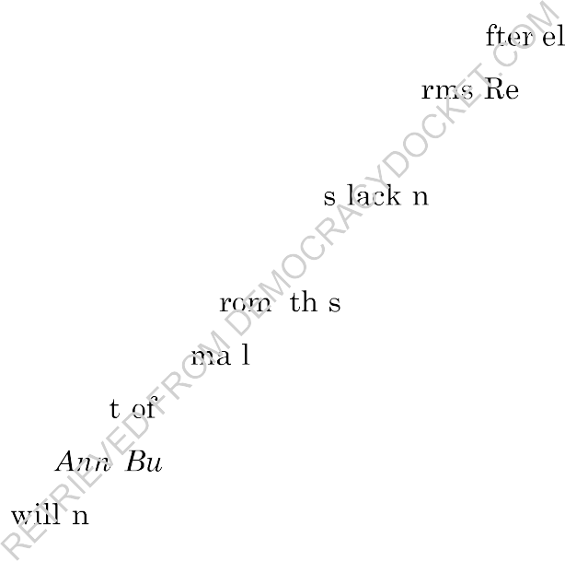
- Totals (Feb. 20, 2024), perma.cc/7NTN-JV6L.
- 59. Accordingly, counting mail ballots received a ection day which lack
- any postmark specifically and disproportionately ha publican candidates and
- Republican voters.
- 60. Harm from counting mail ballot 1 g a postmark that are received
- after election day is irreparable.
- 61. Separate and distinct f 1 lawsuit, Plaintiffs have challenged
- Nevada's counting of late-arriving 1 ballots as violating federal law in the U.S.
- District Court for the Distric Nevada in a case captioned, Republican National
- Committee et al. v. Cari- rgess, et al, No. 24-cv-00198 (D. Nev.). That case
- remains pending and ot impact the state law issues raised in this complaint.
- Should the federal court issue relief that impacts the administration of NRS
- 293.269921(2), Plaintiffs will promptly notify the Court.

FIRST CAUSE OF ACTION

(Declaratory Judgment)
- 62. The preceding paragraphs are incorporated by reference.
- 63. The Plaintiffs seek declaratory relief that mail ballots received after
- election day which lack a postmark shall not be counted.
- 64. The Court has the authority to declare rights, status and other legal

  - rights of the parties, regardless of whether further relief could be had.
  - 65. The facts and issues presented constitute a justiciable controversy, in
  - which the Plaintiffs assert a legally protected interest.
  - 66. The controversy is ripe for determination.
  - 67. Plaintiffs are entitled to relief under NRS 30.010 m the form of a
  - declaration that says:
  - a. Nevada law prohibits the counting of all mail ballots received after
  - election day which lack a postmark; and
  - b. Nevada law prohibits the counting of all mail ballots received after
  - election day which do not bear evidence indicatin they were mailed on
  - or before election day.
  - 68. For the foregoing reasons, the counting o mail ballots received after
  - election day that lack a postmark violates NRS 2 921(1)-(2).
  - 69. Consistent with the requiremen NRS 233B.110(3), Plaintiffs will
  - serve a copy of the Complaint on the Atto General.
  - 70. The Court should theref are the policy and practice of counting
  - mail ballots received after election that lacks a postmark to be invalid.

SEC CAUSE OF ACTION

(Injunctive Relief)
  - 71. The prec paragraphs are incorporated by reference.
  - 72. The coun g of mail ballots received after election day which lack a
  - postmark threatens to immediately deprive Petitioners and Petitioners' members of
  - the rights with respect to a fair election conducted in compliance with Nevada law.
  - 73. Plaintiffs and Plaintiffs' members have no adequate remedy at law.
  - 74. Without injunctive relief, Plaintiffs and Plaintiffs' members will suffer
  - irreparable harm for which compensatory damages are inadequate.
  - 75. The RNC and NVGOP, the Trump Campaign, their members,
  - supporters, and voters, and Mr. Johnston have a significant interest in preventing

- harm that will be created in the upcoming elections by counting mail ballots received
- after election day which lack a postmark.
- 76. Courts have authority "whenever necessary and proper" to grant further
- "relief based on a declaratory judgment or decree," including injunctive relief. NRS
- 30.100. Thus, an injunction can pair with a declaratory judgment under NRS
- 233B.110." Smith v. Bd. of Wildlife Comm'rs, 461 P.3d 164, (Nev 2020) (unpublished);
- Aronoff v. Katleman, 75 Nev. 424, 432 (Nev. 1959) ("[U]nder appropriate
- circumstances, a declaratory judgment may be coupled with injunctive relief.").
- 77. Permanent injunctive relief is appropriate to protect voters rights to a
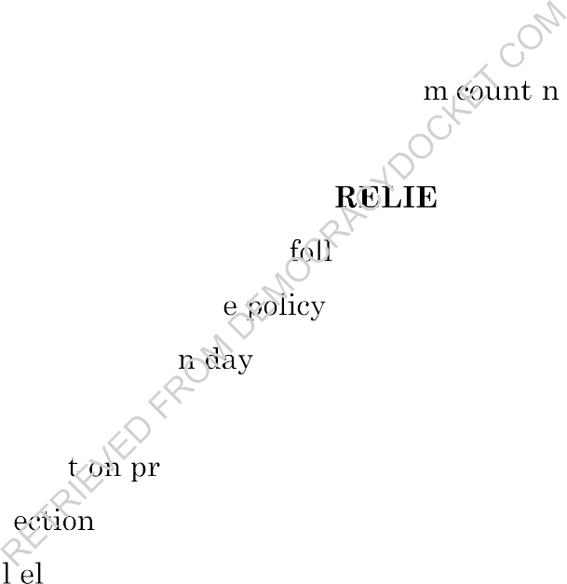
- "uniform, statewide standard for counting and recounting all votes accurately." Nev.
- Const. art. 2 S lA(l0); See also NRS S 293.2546 (5).
- 78. The Court should enjoin Defendants fro 1 g mail ballots received
- after election day which lack a postmark.

PRAYER FOR F
- WHEREFORE, Plaintiff prays for the owing relief:
- A. A declaratory judgment that th and practice of counting of mail
- ballots received after electio that lack a postmark violates NRS
- 293.269921(1)-(2);
- B. A permanent injunc i ohibiting Defendants from counting mail ballots
- received after el day that lack a postmark, including for the November
- 5, 2024, genera ection;
- C. Plaintiffs' reasonable costs and expenses of this action, including attorneys'
- fees; and
- D. All other further relief that Plaintiffs may be entitled to. 25
26
27
28

